SYSTEM REQUIREMENT SPECIFICATIONS FOR CLAIM PROCESSING SYSTEM

PURPOSE OF THE SYSTEM
The Claim processing system is an automated insurance facility for all walks of life. The root of the system starts from registration of the customer. This follows with a series of procedures like inspection and other verifications which ultimately end up with either registration or rejection.

This system is enhancing the facilities provided to the customers by converting it into an automated and online system. The employers can directly register under the Insurance firm online and as far as the rest of the process is concerned, the entire processing of transactions is automated. The access of the data is restricted to un-authorized users of the head office and the branch office. And the official details are kept confidential. The time lag involved in the manual system is completely wiped out. Registering, declaration by the employees and ultimately the claim, payment etc is computerized. Retrieving information and follow up about each aspect becomes easier. The Objective of this system is to provide the functionalities to the policyholders, which is helpful to claim their auto accident and damages of the vehicle online. It facilitates companywide integrated system covering all functional areas of a claim processing.

Introduction
A claim is a legal action to obtain money, property, or the enforcement of a right against another party. The legal document which carries a claim is called a Statement of Claim.
An insurance claim is the actual application for benefits provided by an insurance company. Policy holders must first file an insurance claim before any money can be disbursed to the hospital or repair shop or other contracted service. The insurance company may or may not approve the claim, based on their own assessment of the circumstances.
Individuals who take out home, life, health, or automobile insurance policies must maintain regular payments called premiums to the insurers. Most of the time these premiums are used to settle another person's insurance claim or to build up the available assets of the insurance company. But occasionally an accident will happen which causes real financial damage, such as a automobile or a work-related accident. At this point the injured policy holder has the right to file an insurance claim in order to receive money from the insurance company.
In general, the insurance claim is filed with a local representative of the insurance company. This agent becomes responsible for investigating the specific details of the insurance claim and negotiating the payment from the main insurers. Many times a recognized authority (doctor, repair shop, building contractor) can file the necessary insurance claim forms directly with the insurance company. However, sometimes the policy holder may not want to file an actual insurance claim if the damage is minor or another party has agreed to pay out-of-pocket for their mistake.
After an insurance claim is filed, the insurance company may send out an investigator called an adjustor or surveyor. The insurance adjustor's job is to objectively evaluate the insurance claim and determine if the repair estimates are reasonable. This is to prevent possible fraud by contractors who may inflate their bills for additional compensation. Insurance companies tend to accept the adjustor or appraiser's evaluation as the final word on the insurance claim.
THE EXISTING SYSTEM
Some insurance claims may not be recognized by the insurance company for any number of reasons. If a claimant's premiums have not been paid in full, the policy itself may not be active. Another insurance company may have already agreed to pay for the damages listed in the claim. This happens quite often in automobile accidents where one party is held responsible. Another reason an insurance claim may be rejected is a failure to fall under covered conditions. Most insurance policies spell out specific areas which qualify for benefits. If the accident or damage claim was caused by carelessness or an unavoidable "Act of God", the insurance company has the right to withhold payments.
Existing system is a semi automated system. Here the policy holder needs to apply for any claims he can able to approach the policy office manually. Here the policy holder applies for his insurance claims through paper and submit necessary documents in Xerox copies. The insurer can receive the claim application from the policy holder and stores the information in local system database like ms word, excel etc. To investigate a claim, the surveyor needs to collect the claim request through manually, and submit the claim process details also manually. It is a time delay process to solve more number of claim requests.
Problems of Claim Processing Systems through manually:
1. Program-Data Dependence. Claim descriptions are stored within each application program that accesses a given file.
2. Duplication of Data. Applications are developed independently in file processing systems leading to unplanned duplicate files. Duplication is wasteful as it requires additional storage space and changes in one file must be made manually in all files. This also results in loss of data integrity. It is also possible that the same data item may have different names in different files, or the same name may be used for different data items in different files.
3. Limited data sharing. Each application has its own private files with little opportunity to share data outside their own applications. A requested report may require data from several incompatible files in separate systems.
4. Lengthy Development Times. There is little opportunity to leverage previous development efforts. Each new application requires the developer to start from scratch by designing new file formats and descriptions
5. Excessive Program Maintenance. The preceding factors create a heavy program maintenance load.
6. Integrity Problem. The problem of integrity is the problem of ensuring that the data in the database is accentuate.
7. Inconsistence data
8. Security
PRPOSED SYSTEM

The proposed system is fully automated system here the system need to maintain the centralized database to store the information. Existing system maintain the data in local database only. To share the data from this local database is tedious job. The RDBMS database like SQL Server can able to share the data to all users simultaneously. Policy holder can able to apply a claim request through this online system. The request directly received insurer, and send this request to surveyor directly. Here no need to sending Xerox copies as documents. The policy holder information is stored in centralized database which can be shared by all the users of this system. The time will be reduced while using the centralized database for data sharing.

Our web-based technology empowers your Workers Compensation bill review process with up-to-the-minute information on claims, providers, payments, databases, tables and schedules ensures your claim re-pricing will net the absolute maximum amount allowable.

The claims-processing strategies that support the value chain include these:

- An integrated and. flexible architecture
- Business intelligence enabled by more sophisticated data management, analysis and reporting throughout the enterprise
- Deeper integration of business processes, as well as visibility provided by monitoring, mails and reporting
- Cost-effective migration from legacy systems
- Industry and technology standards

SYSTEM DESIGN
Three tactics to use for giving a system design a future orientation:
- Build redundancy into the current system.
- Maintain a future file on every system.
- Develop documentation.
Logical design
- Produces a system blueprint
- General rather than technical format
Physical design
- Converts the blueprint into the specific detail required to construct the code
- Includes specifying complete descriptions of files, input, and output.
In the flexibility of uses the interface has been developed a graphics concepts in mind, associated through a browser interface. The GUI’s at the top level has been categorized as follows:
- Administrative User Interface Design
- The Operational and Generic User Interface Design (The Insurer, Customer, Surveyor are comes under this category.)
The administrative user interface concentrates on the consistent information that is practically, part of the organizational activities and which needs proper authentication for the data collection. The Interface helps the administration with all the transactional states like data insertion, data deletion, and data updating along with executive data search capabilities.
The operational and generic user interface helps the users upon the system in transactions through the existing data and required services. The operational user interface also helps the ordinary users in managing their own information helps the ordinary users in managing their own information in a customized manner as per the assisted flexibilities.
NUMBER OF MODULES
A module is a bounded contiguous group of statements having a single name and that can be treated as a unit. In other words, a single block in a pile of blocks.

Guidelines for Modularity
- Make sure modules perform a single task, have a single entry point, and have a single exit point.
- Isolate input-output (I-O) routines into a small number of standard modules that can be shared system-wide.
- Isolate system-dependent functions (e.g., getting date or time) in the application to ease possible future conversions to other computer platforms or to accommodate future operating system revisions.
The system after careful analysis has been identified to be presented with the following modules:
- Administrators
- Insurer
- Surveyor
- Customer (Policy Holder)
- Reports
- Authentication
- Search
Module Description
Administrator
1) Can Add Insurance details into the system (like Accident, Fire, General, etc., Fire Insurance in this case).
2) Can Add/Update the Insurer (insurance company) details into the system.
3) Can generate Reports based on Insurance type, Insurer, Surveyor, duration like Monthly & Yearly, etc.

Insurer
1) Will receive the request claim from the Policy Holder for a particular Policy.
2) Will verify the uploaded documents and reviews the documents against the items damaged which are Covered and NOT Covered under the policy.
3) Assign the task to the Surveyor by sending the request details along with attached documents.
4) Should get the Comments of the Surveyor about the survey.
5) He/she can Accept/Reject/Modify the Insurance claim Amount along with necessary remarks.
6) Can update the status of the Insurance claim into the system.

Surveyor
1) Should able to Login to the system.
2) Should Receive the Claim Request details of the Policy Holder along with necessary documents attached.
3) Should able to send back the Comments about the Survey to the Insurer along with Survey Reports.

Policy Holder

1) Customer can register with the Site and login to the site.
2) Can update the details of Insurances has taken against the Assets (like House, Computer, Car, Vehicle, Goods, etc.)
3) Should make the Request for Insurance Claim along with necessary details.
4) Should upload the Police Complaint report as attachment for the Request.
5) Should able to check the Status of Request through online system.

Reports
Various types of reports are generated by the system.
- Claims reports which are processed or not processed
- Accept/Reject Claims Reports
- Claims transactions like monthly, yearly etc.
Search
Search is a module which can be used by all the user of this requirement. Admin can able to search Insurer details, insurance type, surveyor details etc. Insurer can able to search the insurance information and documents of a policy holder while checking the claim request. Policy holder can able to search the status of request through the system interface for his claims.

Authentication
Authentication is nothing but providing security to the system. Here every user must enter into the system throw login page. The login page will restrict the UN authorized users. A user must provide his credential like user Id and password for log into the system. For that the system maintains data for all users. Whenever a user enters his user id and password, it checks in the database for user existence. If the user is exists he can be treated as a valid user. Otherwise the request will throw back.

INPUTS AND OUTPUTS
The major inputs and outputs and major functions of the system are follows:
Inputs:
- Administrator enter his user id and password for login to authenticate in this system
- Administrator Upload new branch details
While upload admin can able to provide branch information like
- Branch Code
- Branch City
- Description
- Date of Register
- Administrator can able to register insurance companies
- Administrator can able to register new claim methods
- New insurance types information uploaded by the insurer
- The surveyors are registered by insurers.
- Customer can able to register in this system, while register they have to provide their details like:
Name, DOB, Contact Number, Address, City
- For recover and change password settings site admin need to submit their log information.
- Insurer, surveyors, Customers updates their website information details using the system user interface.
Outputs:
- Administrator can have his own home page. Insurer, surveyors, customers also can have their own home page after completion of the authentication process.
- Admin get all Register insurer, surveyors, customers Information details.
- The registered user’s data can be stored in centralized database through the system user interface.
- Various types of information can be displayed to the users like Insurance types, claims processing, Branch, city information etc.
- After successful submission of log in information users can got their new password.
SDLC METHDOLOGIES
Mainly there are four phases in the "Spiral Model":
- Planning
- Evolutions
- Risk Analysis
- Engineering
Software Development India
Planning: In this phase, the aims, option and constraints of the project are determined and are documented. The aims and other specifications are fixed so as to determine the strategies/approaches to go after during the project life cycle.
Risk Analysis: It is the most significant phase of "Spiral Model". In this phase the entire possible option that are available and helpful in developing a cost efficient project are analyzed and strategies are determined to employ the available resources. This phase has been added particularly so as to recognize and resolve all the possible risks in the project Claim Processing System. If any indication shows some uncertainty in needs, prototyping may be utilized to continue with the obtainable data and discover out possible software development solution so as to deal with the potential modification in the needs.
Engineering: In this phase, the specific software development of the project is worked out. The output of developed of modules by modules is passed through all the phases iteratively so as to obtain development in the same.
Customer Evaluation: In this phase, before releasing the developed product, the product is passed on to the customer so as to obtain customer’s views and suggestions and if some is left or the desire result is not achieved then all the needs will be identified and resolve all the possible problems/errors in the Farmers Buddy. One can compare it from the TESTING phase.
The spiral model, illustrated in below figure, combines the iterative nature of prototyping with the controlled and systematic aspects of the waterfall model, therein providing the potential for rapid development of incremental versions of the software. In this model the software is developed in a series of incremental releases with the early stages being either paper models or prototypes. Later iterations become increasingly more complete versions of the product.
Depending on the model it may have 3-6 task regions our case will consider a ‘6-task region’ model.
These regions are:
- The User communication task – to establish effective communication between developer and User.
- The planning task – to define resources, time lines and other project related information..
- The risk analysis task – to assess both technical and management risks.
- The engineering task – to build one or more representations of the application.
- The construction and release task – to construct, test, install and provide user support (e.g., documentation and training).
- The User evaluation task – to obtain customer feedback based on the evaluation of the software representation created during the engineering stage and implemented during the install stage.
The evolutionary process begins at the centre position and moves in a clockwise direction. Each traversal of the spiral typically results in a deliverable. For example, the first and second spiral traversals may result in the production of a product specification and a prototype, respectively. Subsequent traversals may then produce more sophisticated versions of the software.
An important distinction between the spiral model and other software models is the explicit consideration of risk. There are no fixed phases such as specification or design phases in the model and it encompasses other process models. For example, prototyping may be used in one spiral to resolve requirement uncertainties and hence reduce risks. This may then be followed by a conventional waterfall development.

- Note that each passage through the planning stage results in an adjustment to the project plan.
- Each of the regions is populated by a set of work tasks called a task set that are adapted to characteristics of the project to be undertaken. For small projects the number of tasks and their formality is low. Conversely, for large projects the reverse is true.
Advantages of the Spiral Model
- The spiral model is a realistic approach to the development of large-scale software products because the software evolves as the process progresses. In addition, the developer and the client better understand and react to risks at each evolutionary level.
- The model uses prototyping as a risk reduction mechanism and allows for the development of prototypes at any stage of the evolutionary development.
- It maintains a systematic stepwise approach, like the classic life cycle model, but incorporates it into an iterative framework that more reflect the real world.
- If employed correctly, this model should reduce risks before they become problematic, as consideration of technical risks are considered at all stages.
Disadvantages of the Spiral Model
- Demands considerable risk-assessment expertise
- It has not been employed as much proven models (e.g. the WF model) and hence may prove difficult to ‘sell’ to the client that this model is controllable and efficient.

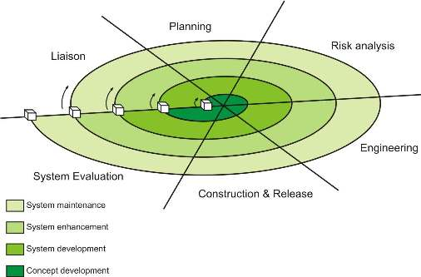

INPUT DESIGN
Input design is a part of overall system design. The main objective during the input design as given below:
Input States: The main input stages can be listed as below:
Data recording, Data transcription, Data conversion, Data verification, Data control, Data transmission, Data validation, Data correction,
Input Media:
At this stage choice has to be made about the input media. To conclude about the input media consideration has to be given to:
Type of Input, Flexibility of Format, Speed, Accuracy, Verification methods, Rejection rates, Ease of correction , Storage and handling requirements, Security, Easy to use, Portability
- A source document differs from a turnaround document in that the former contains data that change the status of a resource while the latter is a machine readable document.
- Transaction throughput is the number of error-free transactions entered during a specified time period.
- A document should be concise because longer documents contain more data and so take longer to enter and have a greater chance of data entry errors.
- Numeric coding substitutes numbers for character data (e.g., 1=male, 2=female); mnemonic coding represents data in a form that is easier for the user to understand and remember. (e.g., M=male, F=female).
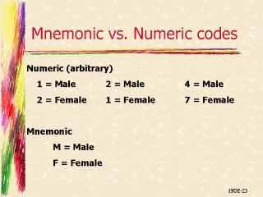
- The more quickly an error is detected, the closer the error is to the person who generated it and so the error is more easily corrected.
- An example of an illogical combination in a payroll system would be an option to eliminate federal tax withholding.
- By "multiple levels" of messages, means allowing the user to obtain more detailed explanations of an error by using a help option, but not forcing a lengthy message on a user who does not want it.
- An error suspense record would include the following fields: data entry operator identification, transaction entry date, transaction entry time, transaction type, transaction image, fields in error, error codes, date transaction reentered successfully.
- A data input specification is a detailed description of the individual fields (data elements) on an input document together with their characteristics (i.e., type and length).

Error Messages to be displayed for the end user

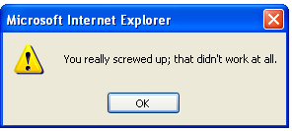
Be specific and precise, not general, ambiguous, or vague. (BAD: Syntax error, Invalid entry, General Failure). Don't JUST say what's wrong---- Be constructive; suggest what needs to be done to correct the error condition.
The following Screen can display how the Farmers buddy can obtain the inputs using the Farmers Buddy User Interface:

OUTPUT DESIGN:
Outputs from computer systems are required primarily to communicate the results of processing to users. They are also used to provide a permanent copy of the results for later consultation. The various types of outputs in general are:
Output Definition:
The outputs should be defined in terms of the following points:
Type of the output, Content of the output, Format of the output, Location of the output, Frequency of the output, Volume of the output, Sequence of the output.
Output is the primary purpose of this system.
These guidelines apply for the most part to both paper and screen outputs. Output design is often discussed before other aspects of design because, from the client's point of view, the output is the system. Output is what the client is buying when he or she pays for a development project. Inputs, databases, and processes exist to provide output.
- Problems often associated with business information output are information delay, information (data) overload, paper domination, excessive distribution, and no tailoring.
- Mainframe printers: high volume, high speed, located in the data center Remote site printers: medium speed, close to end user.
- COM is Computer Output Microfilm. It is more compact than traditional output and may be produced as fast as non-impact printer output.
- Turnaround documents reduce the cost of internal information processing by reducing both data entry and associated errors.
- Periodic reports have set frequencies such as daily or weekly; ad hoc reports are produced at irregular intervals.
- Detail and summary reports differ in the the former support day-to-day operation of the business while the latter include statistics and ratios used by managers to assess the health of operations.
- Page breaks and control breaks allow for summary totals on key fields.
- Report requirements documents contain general report information and field specifications; print layout sheets present a picture of what the report will actually look like.
- Page decoupling is the separation of pages into cohesive groups.
- Two ways to design output for strategic purposes are (1) make it compatible with processes outside the immediate scope of the system, and (2) turn action documents into turnaround documents.
- People often receive reports they do not need because the number of reports received is perceived as a measure of power.
- Fields on a report should be selected carefully to provide uncluttered reports, facilitate 80-column remote printing, and reduce information (data) overload.
- The types of fields which should be considered for business output are: key fields for access to information, fields for control breaks, fields that change, and exception fields.
- Output may be designed to aid future change by stressing unstructured reports, defining field size for future growth, making field constants into variables, and leaving room on summary reports for added ratios and statistics.
- Output can now be more easily tailored to the needs of individual users because inquiry-based systems allow users themselves to create ad hoc reports.
- An output intermediary can restrict access to key information and prevent unauthorized access.
- An information clearinghouse (or information center) is a service center that provides consultation, assistance, and documentation to encourage end-user development and use of applications.
- The specifications needed to describe the output of a system are: data flow diagrams, data flow specifications, data structure specifications, and data element specifications.

Output Documents
- External Reports: for use or distribution outside the organization; often on preprinted forms.
- Internal Reports: for use within the organization.
- Periodic Reports: produced with a set frequency (daily, monthly, etc.)
- Ad-Hoc (On Demand) Reports: irregular interval; produced upon user demand.
- Detail Reports: one line per transaction.
- Summary Reports: an overview.
- Exception Reports: only shows errors, problems, out-of-range values, or unexpected conditions or events.

Output Design Objectives
- Assure Purposeful Output
- Make Meaningful to User
- Provide Appropriate Quantity
- Appropriate Distribution
- Assure Timeliness
- Choose Effective Output Method
CONTEXT LEVEL DIAGRAM
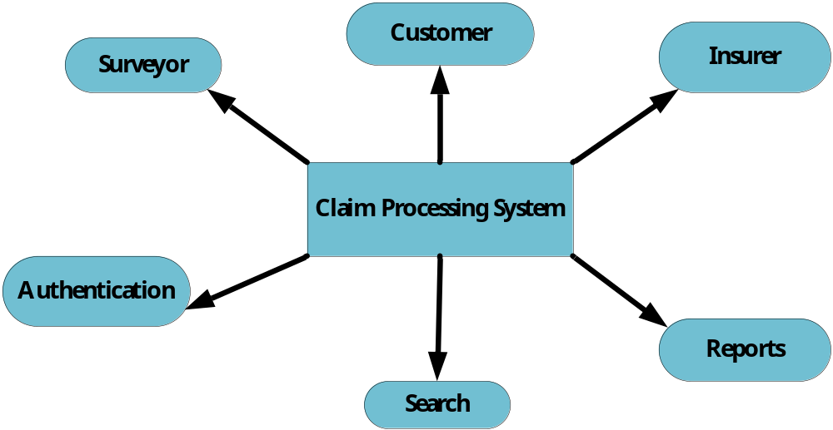

APPLICATION DEVELOPMENT:
N-Tier Applications:
N-Tier Applications can easily implement the concepts of Distributed Application Design and Architecture. The N-Tier Applications provide strategic benefits to Enterprise Solutions. While 2-tier, client-server can help us create quick and easy solutions and may be used for Rapid Prototyping, they can easily become a maintenance and security night mare
The N-tier Applications provide specific advantages that are vital to the business continuity of the enterprise. Typical features of a real life n-tier may include the following:
- Security
- Availability and Scalability
- Manageability
- Easy Maintenance
- Data Abstraction
The above mentioned points are some of the key design goals of a successful n-tier application that intends to provide a good Business Solution.
Definition:
Simply stated, an n-tier application helps us distribute the overall functionality into various tiers or layers:
- Presentation Layer
- Business Object Layer
- Data Access Layer
- Database/Data Store
Each layer can be developed independently of the other provided that it adheres to the standards and communicates with the other layers as per the specifications.
This is the one of the biggest advantages of the n-tier application. Each layer can potentially treat the other layer as a ‘Block-Box’.
In other words, each layer does not care how other layer processes the data as long as it sends the right data in a correct format.
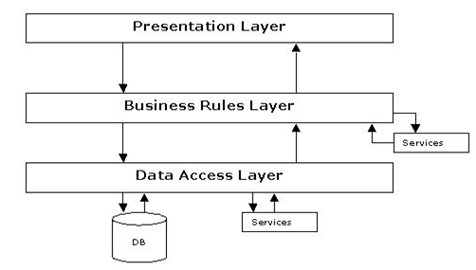
Fig 1.1-N-Tier Architecture
The Presentation Layer:
Also called as the client layer comprises of components that are dedicated to presenting the data to the user. For example: Windows/Web Forms and buttons, edit boxes, Text boxes, labels, grids, etc.
The Business Object Layer:
This layer encapsulates the Business rules or the business logic of the encapsulations. To have a separate layer for business logic is of a great advantage. This is because any changes in Business Rules can be easily handled in this layer. As long as the interface between the layers remains the same, any changes to the functionality/processing logic in this layer can be made without impacting the others. A lot of client-server apps failed to implement successfully as changing the business logic was a painful process.
The Data Access Layer:
This layer comprises of components that help in accessing the Database. If used in the right way, this layer provides a level of abstraction for the database structures. Simply put changes made to the database, tables, etc do not affect the rest of the application because of the Data Access layer. The different application layers send the data requests to this layer and receive the response from this layer.
The Database Layer:
This layer comprises of the Database Components such as DB Files, Tables, Views, etc. The Actual database could be created using SQL Server, Oracle, Flat files, etc.
In an n-tier application, the entire application can be implemented in such a way that it is independent of the actual Database. For instance, you could change the Database Location with minimal changes to Data Access Layer. The rest of the Application should remain unaffected
PERFORMANCE REQUIREMENTS:
Performance is measured in terms of the output provided by the application. Requirement specification plays an important part in the analysis of a system. Only when the requirement specifications are properly given, it is possible to design a system, which will fit into required environment. It rests largely in the part of the users of the existing system to give the requirement specifications because they are the people who finally use the system. This is because the requirements have to be known during the initial stages so that the system can be designed according to those requirements. It is very difficult to change the system once it has been designed and on the other hand designing a system, which does not cater to the requirements of the user, is of no use.
- The requirement specification for any system can be broadly stated as given below:
- The system should be able to interface with the existing system
- The system should be accurate
- The system should be better than the existing system
- The existing system is completely dependent on the user to perform all the duties.

FEASIBILITY REPORT:
Preliminary investigation examine project feasibility, the likelihood the system will be useful to the organization. The main objective of the feasibility study is to test the Technical, Operational and Economical feasibility for adding new modules and debugging old running system. All system is feasible if they are unlimited resources and infinite time. There are aspects in the feasibility study portion of the preliminary investigation:
A feasibility study assesses the economic, technical, and operational merits of the proposed project. A project is economically feasible if costs do not overshadow benefits. A project is technically feasible if the technology is available and capable of meeting users' requests. A project is operationally feasible if the proposed system will operate and be used once it is installed.
- Technical Feasibility
- Operation Feasibility
- Economical Feasibility
Technical Feasibility
The technical issue usually raised during the feasibility stage of the investigation includes the following:
Does the necessary technology exist to do what is suggested?
Do the proposed equipments have the technical capacity to hold the data required to use the new system?
Will the proposed system provide adequate response to inquiries, regardless of the number or location of users?
Can the system be upgraded if developed?
Are there technical guarantees of accuracy, reliability, ease of access and data security?
Earlier no system existed to cater to the needs of ‘Secure Infrastructure Implementation System’. The current system developed is technically feasible. It is a web based user interface for audit workflow at NIC-CSD. Thus it provides an easy access to the users. The database’s purpose is to create, establish and maintain a workflow among various entities in order to facilitate all concerned users in their various capacities or roles. Permission to the users would be granted based on the roles specified. Therefore, it provides the technical guarantee of accuracy, reliability and security. The software and hard requirements for the development of this project are not many and are already available in-house at NIC or are available as free as open source. The work for the project is done with the current equipment and existing software technology. Necessary bandwidth exists for providing a fast feedback to the users irrespective of the number of users using the system.
Operational Feasibility
Proposed projects are beneficial only if they can be turned out into information system. That will meet the organization’s operating requirements. Operational feasibility aspects of the project are to be taken as an important part of the project implementation. Some of the important issues raised are to test the operational feasibility of a project includes the following: -
Is there sufficient support for the management from the users?
Will the system be used and work properly if it is being developed and implemented?
Will there be any resistance from the user that will undermine the possible application benefits?
This system is targeted to be in accordance with the above-mentioned issues. Beforehand, the management issues and user requirements have been taken into consideration. So there is no question of resistance from the users that can undermine the possible application benefits.
The well-planned design would ensure the optimal utilization of the computer resources and would help in the improvement of performance status.
Economic Feasibility
A system can be developed technically and that will be used if installed must still be a good investment for the organization. In the economical feasibility, the development cost in creating the system is evaluated against the ultimate benefit derived from the new systems. Financial benefits must equal or exceed the costs. The system is economically feasible. It does not require any addition hardware or software. Since the interface for this system is developed using the existing resources and technologies available at NIC, There is nominal expenditure and economical feasibility for certain.

